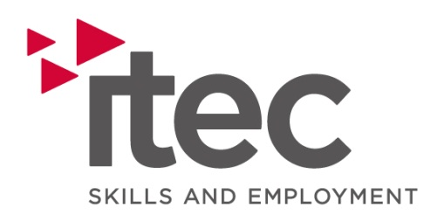

Job Description

Title: Youth Tutor

Summary/Purpose: To provide a learning and employability framework to Youth learners, ensuring the attainment of positive outcomes through the delivery of classroom and vocational assessment and training.

Reporting to: Area Manager

Duties and Responsibilities:

Specific
- Conduct initial interviews including assessment activities with learners using a range of tools
- Deliver induction to all allocated new starts including digital platforms/curriculum/qualifications.
- Plan the learning and assessment process with learners, observing and recording assessments completing all relevant documentation.
- Complete and maintain accurate learner records
- Deliver sessions which include direct teaching and the use of a variety of teaching strategies .
- Develop and utilise lesson plans for each taught session incorporating topics relating to whole class teaching, individual, paired, group and differentiated activities
- Provide focused support to those learners who are pre-entry level, or may have specific learning needs
- Achieve appropriate qualifications in a timely manner
- Working closely with the learners’ Lead Worker to identify progression opportunities.
- Completion of all training and learner related documentation and paperwork to ensure correct content and accuracy, including monthly reviews of progress.
- To support all administration duties as required.
- Work as part of a team to ensure a quality learner experience
- Maintain knowledge and adherence to Work Based Learning Professional Standards, Education Workforce Code of Practice and company’s Code of Conduct
General
- To ensure security of company assets
- To comply with all company policies and procedures
- To comply with the companies safeguarding policy & procedure
- To comply with Equal Opportunities Legislation and be proactive in challenging prejudice, discrimination and stereotyping.
- To implement in full the Company’s quality policies and procedures.
- To consult the Company Health and Safety Policy with regards to their specific responsibilities as described in the general arrangements section
- To give consideration to their actions at work as to how they may affect the safety of Learners, clients and visitors to Company premises
- Support and demonstrate the organisations core values
- Ownership mindset. Demonstrates accountability and reliability, taking responsibility for own actions and timely achievement of KPI’s.
- Co-operate with all staff to achieve a healthy and safe workplace and reporting any risks identified, at the company’s or others premises, to the designated Health and Safety Officer.
- Other duties that may be identified from time to time by the Company.
- Attend relevant training / personal development programmes
- Promote Itec at every opportunity with all stakeholders including learners and employers.

Person Specification
 | Essential | Desirable
Experience & Qualifications | Previous experience working as a tutor, trainer, or mentor for young people.  Previous experience working with NEET (Not in Education, Employment, or Training) individuals  Minimum Level 3 qualification in Education, Youth Work, or a related field.  Good level of Math and English GCSE C, Level 5 or above | PGCE, PCET or equivalent teaching/training qualification.  Experience teaching a vocational subject (e.g., Employability, business, IT, or customer service).
Skills | Ability to engage, motivate, and support young people in a learning environment.  Ability to plan lessons, assess learner progress, and provide feedback effectively.  Good organisational skills.  Good communication and interpersonal skills.  Ability to develop course material. | Welsh Language Skills
Knowledge | Safeguarding & Prevent Knowledge and understanding | Awareness of the Jobs Growth Wales Plus initiative and how it supports youth employment.  Familiarity with CV writing, interview preparation, and job search skills.
Characteristics | Empowers others  Demonstrates a passion for learning  Demonstrates a commitment to inclusion  Fosters growth by proactively improving processes and practices  Self-motivated, self starter.  Flexible in approach.  Ability to work under pressure  Reliable  Enthusiastic  Team player  Flexible to change

